Complaints by Zipcode

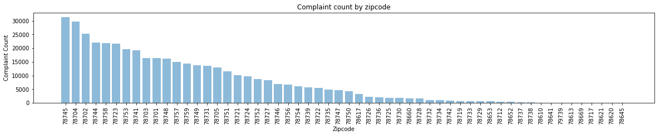

The maximum number of complaints are from

* 78745: Sunset valley
* 78704: Barton springs, zilker park areas

Population vs complaint count

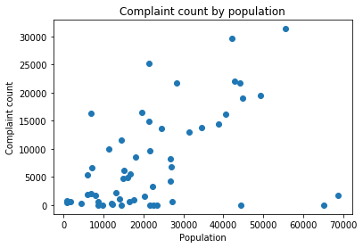

Outliers

* 78660: Pflugerville, small portion in Williamson county
* 78613: Cedar park, in Williamson county
* 78641: Leander, in Williamson county

|  |  |  |  |
| --- | --- | --- | --- |
| **zip_code** | **complaint_count** | **total_population** |  |
| 78702 | 25203 | 21334 |  |
| 78723 | 21723 | 28330 |  |
| 78757 | 14883 | 21310 |  |
| 78731 | 13582 | 24614 |  |
| 78724 | 9734 | 21696 |  |
| 78727 | 8245 | 26689 |  |
| 78746 | 6872 | 26928 |  |
| 78750 | 4236 | 26814 |  |
| 78617 | 3276 | 22210 |  |
| 78728 | 1549 | 20299 |  |
| 78729 | 563 | 27108 | Jollyville |
| 78610 | 31 | 23502 | Buda |
| 78717 | 2 | 22538 | Avery Ranch |
| 78621 | 1 | 21659 | Elgin |

Improvement

* Represent county by different colors?
* Find out how 311 calls are diverted

Median household income vs complaint count

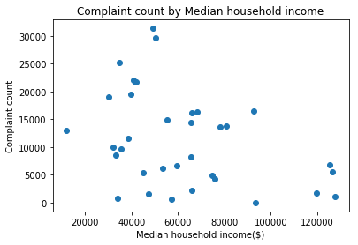

Remove population as a factor by looking into only those zip-codes with population between 20K & 30K

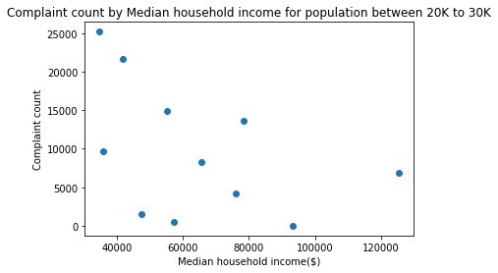

Improvement

* Stylize graph

Complaint count vs population below poverty level

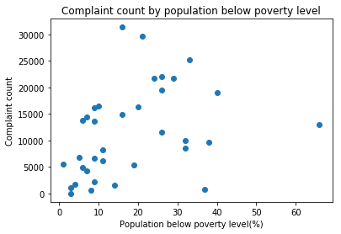

Not sure if this is relevant/useful

Complaint count vs crime rate

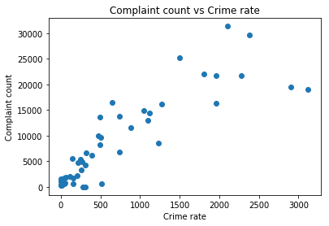

Same plot for population between 20K-30K

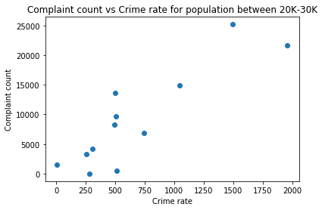

Improvement

* Represent income group by color?

Further Work

* Arrive at conclusions for each plot
* Find data for % of rental property by zip-code
* Find any other zip-code related data & see if it is relevant
* Stylize graphs & see if there are better ways to represent the data
* Explore opportunities for statistical analysis on the data